Resource & cost Handling for Agriculture

**Problem statement:-**

Problems and Constraints faced by farmers in financing and marketing of agricultural Produce.

**Our Solution:-**

**Introduction**

India is an Agricultural Nation.Reports indicate that 71.6 % of farmer’s source of income are from agriculture sectors.Its commitment to Gross Domestic item (GDP) is between 14 to 15%.The present paper attempts to spell out some of the constraints like production, Storage and finance-related problems faced by the farmers. Primary data were collected from the farmers portal(Govt.Verified) for investigation to predict solutions to overcome the Financial challenges faced by farmers. This report is exclusive to Odisha state only for the time.This investigation Process can be addressed by dynamic cost analysis of end-to-end agriculture process.The 10 years data-set of cost of cultivation/production of crops are analyzed and put in to ML prediction model.Individual farmer’s info of land holdings and resources are taken as inputs. The appropriate crop for farming is retrieved from crop Recommendation system.

**Objectives**

To conduct a pilot to examine whether machine learning can be used for:-

1. Forecasting the modal cost of Cultivation/ Production/ Operational/ Materials for the selected crops in advance using machine learning at the selected region across India

2. Forecasting the MSP of selected Crop and determine the profit margin made by farmers.

**Project Approach**

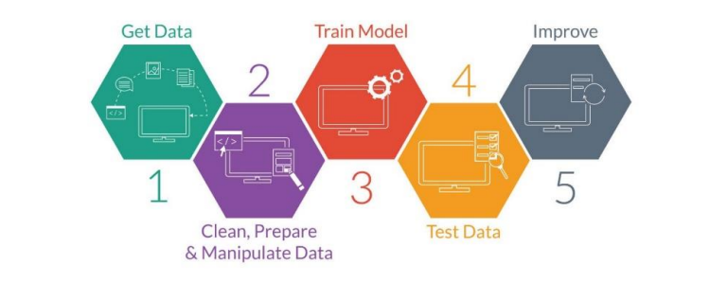

▪ **Identify determinants and acquire data:** Interviews with domain experts, identification of influencing factors and delivery of historical data from key stakeholders.

**▪ Prepare data:** Clean and transform the downloaded data into a machine readable format.

▪ **Train model:** Developing multiple price prediction algorithms.

▪ **Test model:** Testing the output of the algorithms and shortlisting best performing algorithms.

▪ **Deploy and live testing:** Deploy the algorithm for live testing over a period and further improvement using key learning.

We have tried two models: 1. FB Profit

2.Time Series analysis

and based on the accuracy choose Time Series for the Model.Hyper-parameters used to end-to-end agricultural process are:

|  |  |
| --- | --- |
| **Sl No** | **Parameters for ML Model** |
| I-1.1 | Cost of Cultivation (Rs./Hectare) |
| 2.1 | Cost of Production (Rs./Qty) |
| 3.0 | Value of Main Product (Rs./Hectare) |
| 4.0 | Value of By- Product (Rs./Hectare) |
| 5.0 | **Material & Labour Input per Hectare** |
| 5.1 | Seed (Kg.) |
| 5.2 | Fertilizer (Kg. Nutrients) |
| 5.3 | Manure (Qty.) |
| 5.4 | Human Labour* (Man Hrs.) |
| 5.5 | Animal Labour (Pair Hrs.) |
| **II** | **Item wise Breakup Cost of Cultivation (Rs. per Hectare)** |
| 6.0 | Operational Cost |
| 6.1 | Human Labour (Total) |
| 6.2 | Animal Labour (Total) |
| 6.3 | Machine Labour (Total) |
| 6.4 | Seed |
| 6.5 | Fertilizer & Manure (Total) |
| 6.6 | Insecticides |
| 6.7 | Irrigation Charges |
| 6.8 | Miscellaneous |
| 6.9 | Interest on Working Capital |
| 7.0 | Inventory charges |

The Time Series ML model predicts all the cost for all parameters with 80% accuracy.With this we can solve the problem with a well-made budget with options for Organic farming methods to minimize expenses and maximize profit.

**Technologies required-**

1. Python Pandas
2. Scikit learn for Time Series Analysis ML model
3. MS Excel
4. Jupyter Notebook

**Team Members-**

1. Dibyajyoti Swain (Team lead)
2. Ashis Ray
3. Prajnanam Nayanabhiram Mohanty
4. Isha Das